EXPERIMENTS

NAME:BHARANI DHARAN S
REG NO:192424141
COURSE CODE:DSA0602:DATA HANDLING AND VISUALIZATION

Set 1: Monthly Sales Data:

Month | Sales ($)
January | 15000
February | 18000
March | 22000
April | 20000
May | 23000

QUESTION 1
Create a line chart to visualize the monthly sales. Label the axes and title the chart appropriately.

AIM
To create a line chart using R programming to visualize the monthly sales data.

PROCEDURE
- Open R/RStudio.
- Create vectors for months and sales.
- Use the plot() function to create a line chart.
- Give suitable labels for the X-axis and Y-axis.
- Add a title and display the sales values.
- Execute the program and observe the output.
CODE

month <- c("January", "February", "March", "April", "May")
sales <- c(15000, 18000, 22000, 20000, 23000)

plot(sales,
type = "o",
xaxt = "n",
xlab = "Month",
ylab = "Sales ($)",
main = "Monthly Sales")

axis(1, at = 1:5, labels = month)

OUTPUT
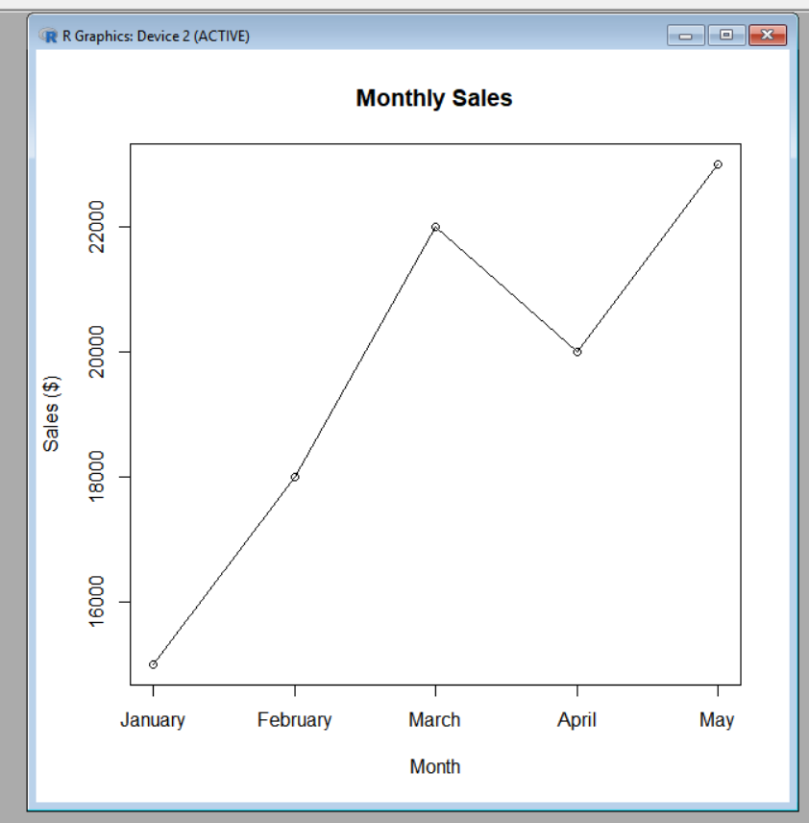

RESULT
Thus, the monthly sales data was successfully visualized using a line chart in R, with appropriate title and axis labels.

QUESTION 2

Generate a bar chart to display the top-selling products for the year. Label the chart elements.

AIM
To create a bar chart in R programming to display the monthly sales data and label the chart appropriately.

PROCEDURE
- Start RStudio.
- Create vectors for the months and sales.
- Use the barplot() function to create the bar chart.
- Give a suitable title to the chart.
- Label the X-axis and Y-axis.
- Display the sales values on the bars.
- Run the program and observe the output in the Plots window.

CODE

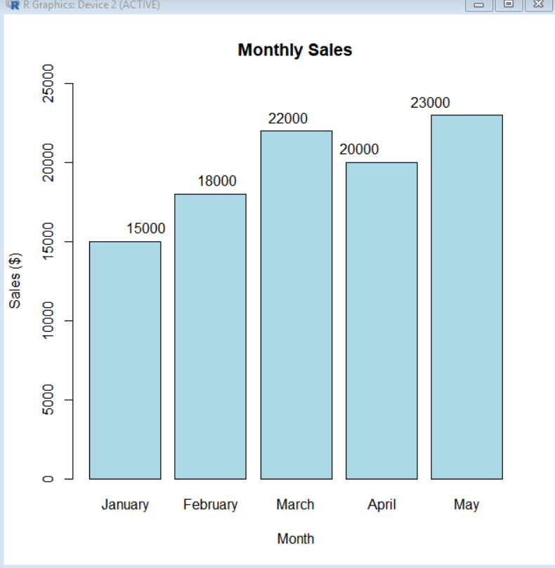

RESULT
Thus, the monthly sales data was successfully represented using a bar chart in R, with appropriate labels and sales values displayed on the bars.

QUESTION 3

Develop a scatter plot to explore the relationship between advertising budget and monthly sales. Explain the insights drawn from the scatter plot.

AIM
To create a scatter plot in R to study the relationship between advertising budget and monthly sales.

PROCEDURE
- Create vectors for advertising budget and sales.
- Use the plot() function to create a scatter plot.
- Place advertising budget on the X-axis.
- Place sales on the Y-axis.
- Add a suitable title and axis labels.
- Run the program and observe the scatter plot.
- Analyze the relationship between advertising budget and sales.

CODE
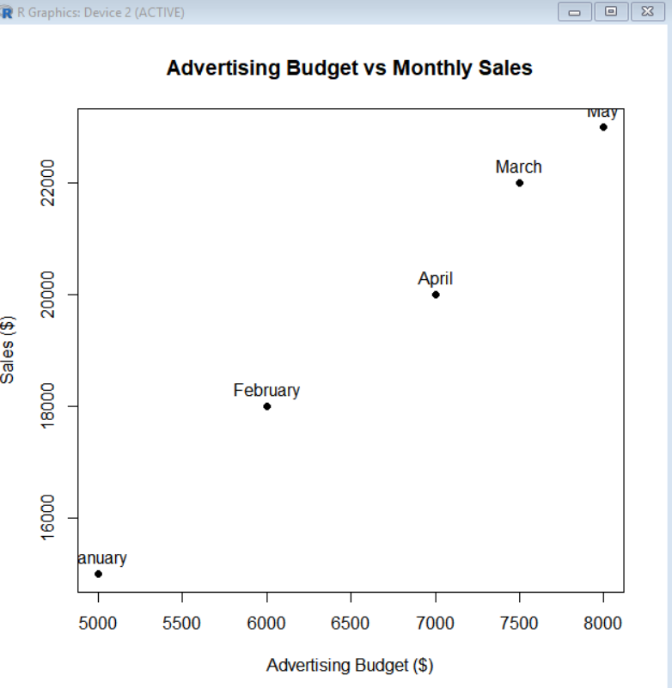

RESULT
Thus, the scatter plot was successfully created in R. The plot shows that higher advertising budgets are generally associated with higher monthly sales in the sample data.

QUESTION 4

Build an interactive dashboard combining the line chart and bar chart to allow users to explore sales data interactively.

AIM
To create an interactive sales dashboard in R containing a line chart and bar chart for exploring monthly sales.

PROCEDURE
- Install and load the shiny package.
- Create the monthly sales dataset.
- Create a user interface containing a month-selection option.
- Create a server section to generate the line and bar charts.
- Combine both charts in the dashboard.
- Run the Shiny application.
- Select different months to explore the sales data.

CODE
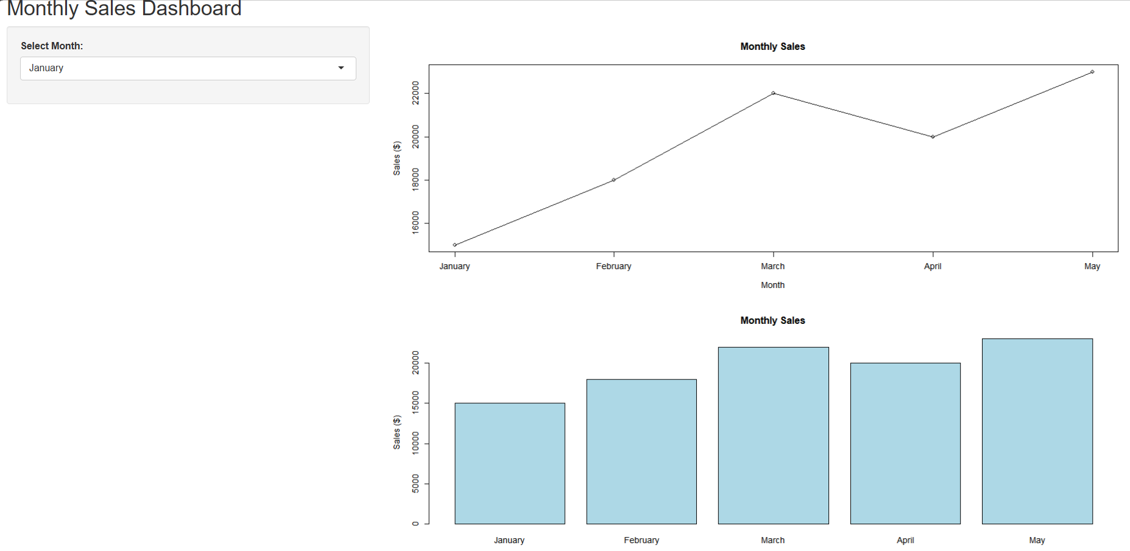

RESULT
Thus, an interactive monthly sales dashboard was successfully created using R and Shiny, combining line and bar charts for exploring the sales data.

